KTP Measurements
Name: ____________________________
Address: __________________________
__________________________________
Contact Details:_____________________
Overall Height: _____________________

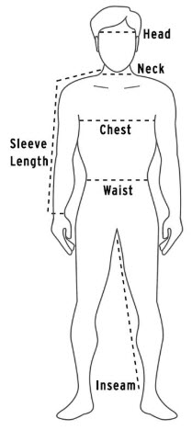
Mitre: Head circumference …________cm
Tunic: Shoulder to below the knee: ______cm
Mantle: shoulder to shin: ___________cm
Chest: ___________cm

Tunic to here

Mantle to here

